
Press Release
INDIGO 2026: Moonlight Peaks Wins INDIGO Award as 900 Industry Professionals Gather in Rotterdam (NL)
Rotterdam, Netherlands – June 4th, 2026 – Moonlight Peaks, developed by Little Chicken Game Company, has taken home the prestigious INDIGO 2026 Award. The game where players raise mystical crops, learn spell-casting and potion-making, and befriend or even romance werewolves, witches, and mermaids was selected by a professional jury from a pool of 25 competing titles showcased at INDIGO 2026.
The two-day conference brought together over 900 industry professionals, government representatives, and stakeholders at the World Trade Center in Rotterdam (NL). Attendees enjoyed a packed program, featuring 30+ talks from renowned industry figures, 25 new games on the DISCOVER Showcase, and sharing new concepts during Pitch Perfect.
The exhibition floor buzzed with networking, deal-making through MeetToMatch, and opportunities to reconnect with old friends while meeting new faces. INDIGO has firmly established itself as a cornerstone of the Benelux game industry ecosystem.
“As INDIGO 2026 draws to a close, we are left with immense pride and gratitude. Seeing more than 900 people from all corners of the world come together in Rotterdam to celebrate, support and engage with the Benelux game industry is truly special. What makes INDIGO meaningful is not just the number of visitors, but the positive energy, generosity and collaborative spirit that everyone brings into the room. That is the community we are proud to be part of.”– Martine Spaans, Board Member of the Benelux Games Promotional Initiative (BGPI)

INDIGO 2026 has been made possible with the support of:
City of Rotterdam, Dutch Game Association and Flanders Audiovisual Fund (VAF)
INDIGO 2026 is sponsored by:
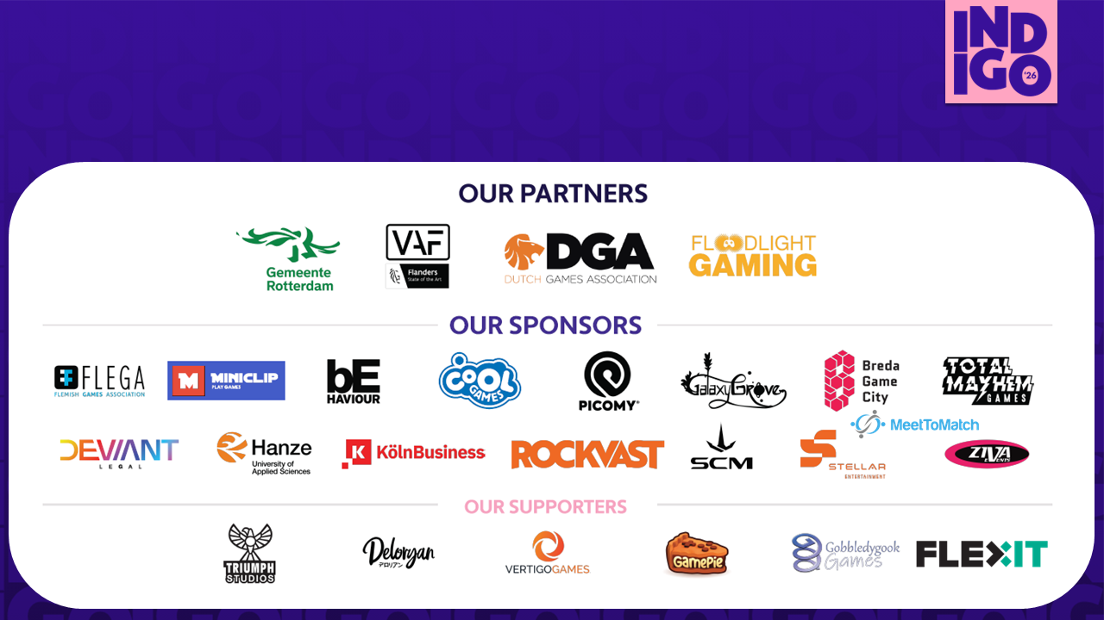

--------------------------------------------------------------------

About INDIGO
INDIGO is the premier business event for the Benelux game industry, connecting game developers, publishers, investors and industry professionals through networking, showcases and expert talks. Organized by the Benelux Games Promotional Initiative (BGPI), INDIGO provides a key platform for business opportunities, international collaboration and industry growth. Since 2025, INDIGO has taken place in Rotterdam and expanded into a two-day event. The 2026 edition was held on June 2 and 3 at World Trade Center Rotterdam.
For more information: https://indigoshowcase.nl/
---------------------------------------------------

Press contact
Geoff van den Ouden
Chairman - BGPI
Email: geoff@bpi.org
Phone: +31620507631

